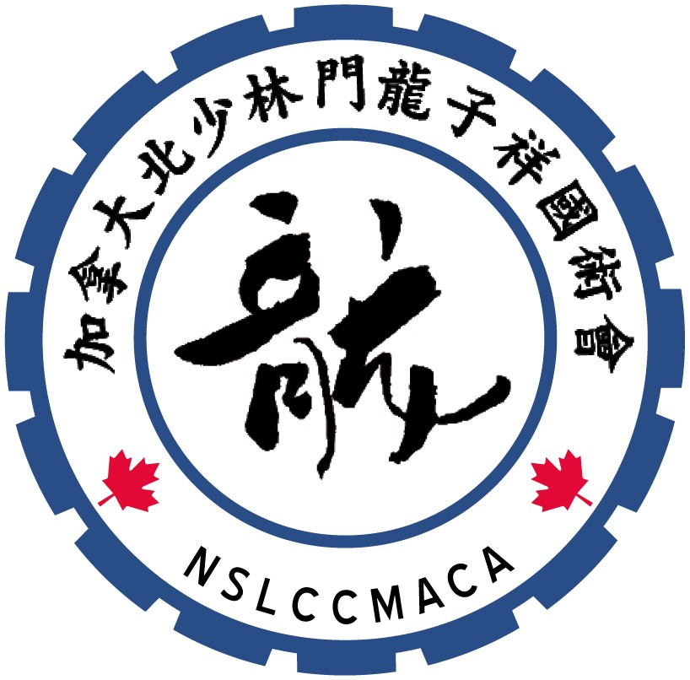
Northern Shaolin
Lung Chi Cheung Martial Arts (Canada) Association
www.northernshaolin.com
info@northernshaolin.com
(604) 808-9168

Notice of Annual General Meeting
Notice to Members is hereby given of the Annual General Meeting
of the Northern Shaolin Lung Chi Cheng Martial Arts (Canada) Association,
to be held in Vancouver, BC at 3:00 p.m. on Saturday, November 7, 2026
Location:
Pool Multi-Purpose Room
Killarney Community Centre
6250 Killarney Street, Vancouver

3:00 pm Members Sign-In and Refreshments Served
3:15 pm AGM begins

Dear Association Members and Kung Fu and Tai Chi Students,

I would like to encourage students 16 years and older and parents of younger Kung Fu students to participate in the AGM, as well as to consider a position on the Board of Directors. The commitment is not huge - meetings are generally once every two months. As a director, you will have an opportunity to directly influence Association activities and the delivery of the martial arts experience to all the students!

A Member’s Package, including the agenda for the AGM and all the relevant documents will be available on the Association Website (www.northernshaolin.com). During the AGM, you will be asked to elect Directors of the organization. Nominations will be accepted from the floor during the AGM.

Thank you and we look forward to seeing you at the AGM on November 7th!

Sifu Marquis Lung
President
NSLCCMACA

